**Chapter 1 – Functions**

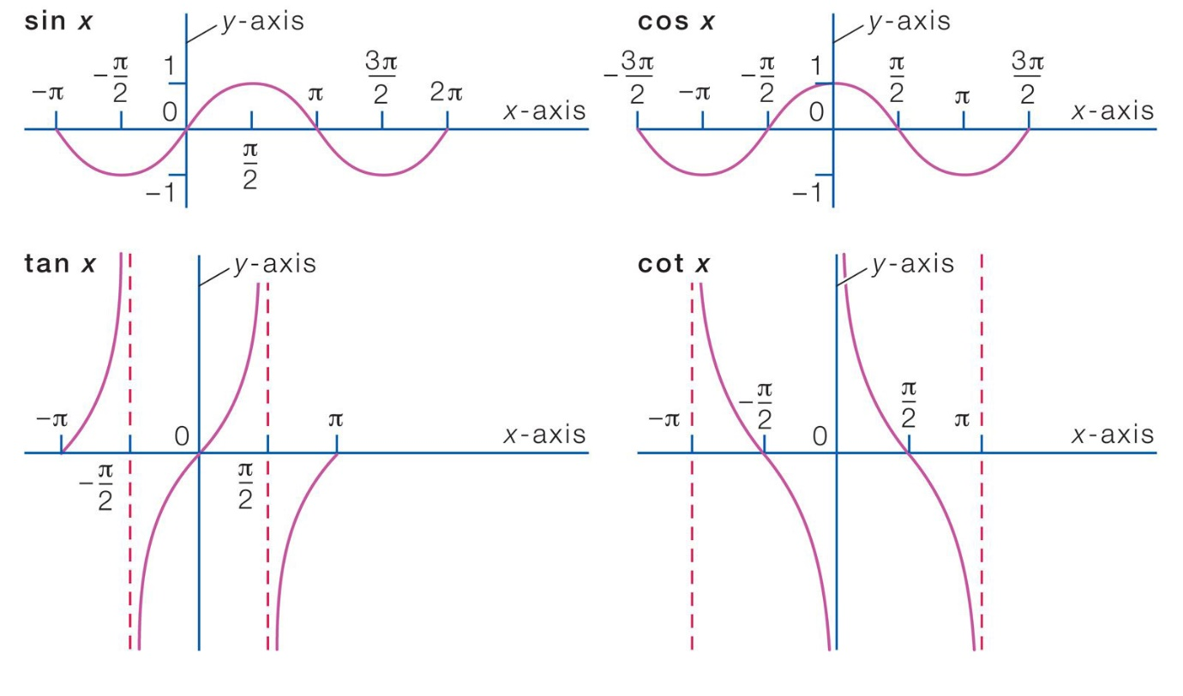

**OVERVIEW** Functions are fundamental to the study of calculus. In this chapter we review what functions are and how they are pictured as graphs, how they are combined and transformed, and ways they can be classified. We review the trigonometric functions, and we discuss misrepresentations that can occur when using calculators and computers to obtain a function’s graph. We also discuss inverse, exponential, and logarithmic functions. The real number system, Cartesian coordinates, straight lines, circles, parabolas, and ellipses are reviewed in the Appendices.

**Functions and Their Graphs**

Functions are a tool for describing the real world in mathematical terms. A function can be represented by an equation, a graph, a numerical table, or a verbal description; we will use all four representations throughout this book. This section reviews these function ideas.

**Functions; Domain and Range**

The temperature at which water boils depends on the elevation above sea level (the boiling point drops as you ascend). The interest paid on a cash investment depends on the length of time the investment is held. The area of a circle depends on the radius of the circle. The distance an object travels at constant speed along a straight-line path depends on the elapsed time.

In each case, the value of one variable quantity, say y, depends on the value of another variable quantity, which we might call x. We say that “y is a function of x” and write this

symbolically as

y = ƒ(x) (“y equals ƒ of x”).

In this notation, the symbol ƒ represents the function, the letter x is the independent variable representing the input value of ƒ, and y is the dependent variable or output value of ƒ at x. The set D of all possible input values is called the domain of the function. The set of all output values of ƒ(x) as x varies throughout D is called the range of the function. The range may not include every element in the set Y. The domain and range of a function can be any sets of objects, but often in calculus they are sets of real numbers interpreted as points of a coordinate line. (In Chapters 13–16, we will encounter functions for which the elements of the sets are points in the coordinate plane or in space.)

Often a function is given by a formula that describes how to calculate the output value from the input variable. For instance, the equation A = pr2 is a rule that calculates the area A of a circle from its radius r (so r, interpreted as a length, can only be positive in this formula). When we define a function y = ƒ(x) with a formula and the domain is not stated explicitly or restricted by context, the domain is assumed to be the largest set of real x-values for which the formula gives real y-values, which is called the natural domain. If we want to restrict the domain in some way, we must say so. The domain of y = x2 is the entire set of real numbers. To restrict the domain of the function to, say, positive values of x, we would write “y = x2 , x 7 0.” Changing the domain to which we apply a formula usually changes the range as well. The range of y = x2 is [0, q). The range of y = x2 , x Ú 2, is the set of all numbers obtained by squaring numbers greater than or equal to 2. In set notation (see Appendix 1), the range is 5x2 x Ú 26 or 5y y Ú 46 or 34, q). When the range of a function is a set of real numbers, the function is said to be real-valued. The domains and ranges of most real-valued functions of a real variable we consider are intervals or combinations of intervals. The intervals may be open, closed, or half open, and may be finite or infinite. Sometimes the range of a function is not easy to find. A function ƒ is like a machine that produces an output value ƒ(x) in its range whenever we feed it an input value x from its domain (Figure 1.1). The function keys on a calculator give an example of a function as a machine. For instance, the 2x key on a calculator gives an output value (the square root) whenever you enter a nonnegative number x and press the 2x key. A function can also be pictured as an arrow diagram (Figure 1.2). Each arrow associates an element of the domain D with a unique or single element in the set Y. In Figure 1.2, the arrows indicate that ƒ(a) is associated with a, ƒ(x) is associated with x, and so on. Notice that a function can have the same value at two different input elements in the domain (as occurs with ƒ(a) in Figure 1.2), but each input element x is assigned a single output value ƒ(x).